Oleynik Vladislav

Exercise 14

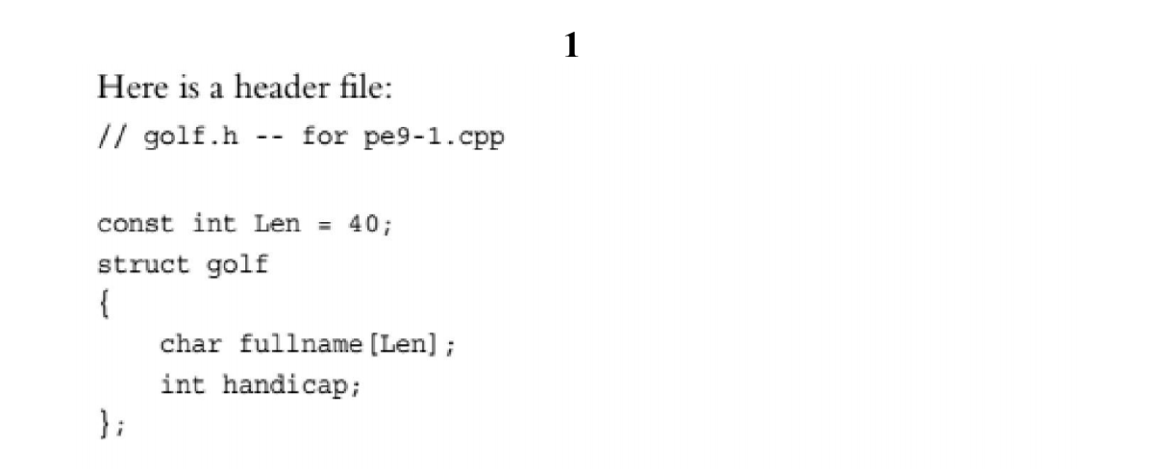

golf.cpp

#include "golf.h"

#include <cstring>

#include <iostream>

using namespace std;

void setgolf(golf &g, const char *name, int hc)

{

strcpy(g.fullname, name);

g.handicap = hc;

}

int setgolf(golf &g)

{

cout << "Enter name: ";

cin.getline(g.fullname, Len);

cout << "Enter handicap: ";

(cin >> g.handicap).get();

return strlen(g.fullname) == 0 ? 0 : 1;

}

void handicap(golf &g, int hc)

{

g.handicap = hc;

}

void showgolf(const golf &g)

{

cout << "Name: " << g.fullname << endl;

cout << "Handicap: " << g.handicap << endl;

}

golf.h

#pragma once

#ifndef GOLF_H_

#define GOLF_H_

const int Len = 40;

struct golf

{

char fullname[Len];

int handicap;

};

void setgolf(golf &g, const char *name, int hc);

int setgolf(golf &g);

void handicap(golf &g, int hc);

void showgolf(const golf &g);

#endif

index.cpp

#include <iostream>

#include "golf.h"

int main()

{

using namespace std;

golf golfers[3];

int numCollected = 0;

for (int i = 0; i < 3; i++)

{

cout << "Golfer #" << i + 1 << endl;

if (!setgolf(golfers[i]))

{

break;

}

numCollected++;

}

cout << "\n\n\n"

<< numCollected << " golfers were entered." << endl;

for (int i = 0; i < numCollected; i++)

{

showgolf(golfers[i]);

}

cout << "\n\n\n";

golf tiger;

const char *name = "Tiger Woods";

int hcap = 24;

setgolf(tiger, name, hcap);

showgolf(tiger);

handicap(tiger, 25);

showgolf(tiger);

return 0;

}

Output:

